l, 2021 Term 2 Week 2

Greetings everyone

It was great to see so many of you at Parent Teacher Interviews. I hope you found the experience useful for you and your child. If you have any feedback on how we could do the process better please contact me at principal@kingsview.school.nz. School reports will be coming out at the end of this term.

We’ve had swimming lessons down at the Events Centre for the last two Fridays and the children have really enjoyed it. There have been lots of priceless smiles and giggles as they learn new skills and gain confidence in the water - essential for life in Queenstown, although I don’t see too many people in the lake at the moment.

I’ll be back with my family in Palmerston North next week and will be working on-line for the school. Any issues - please hold them till I get back (Monday, Week 4), or, if you need to contact me I’m available from my cell phone - just ask the office (I can have zoom meetings). Victoria Stevens will be in charge while I’m away.
This will happen in Weeks 3, 6 and 9 of this term.

Skiing This Year

Skiing is a big part of life in Queenstown, as I’m learning, and schools in Queenstown have been working with NZ Ski to offer an extremely good package for the students. This will be in Term 3 and it will not be part of the normal school program, but parents will have the discretion to take their children out of school and to participate in skiing at this time.

The dates for our school at Remarkables Ski field are:

Yrs 3 & 4 children 16 -18 August - Term 3, Week 4
Yrs 5 & 6 children 23 - 25 August - Term 3, Week 5
Yrs 7 & 8 children 30 Aug - 1 Sept - Term 3, Week 6

The program is called the 3-day Local Schools Program 2021 and is held at Remarkables Ski Field. The students enrol with NZSKI ($160) and must also purchase a local ski pass ($104). There will be a system of buses which likely will leave from Remarkables School, but the basic information is that the actual lesson sessions run 10:30-2pm up the mountain with 30 mins for lunch.
If you are enrolling your child for this program, they will be under theskiNZ supervision, please let the school know for attendance purposes.

To purchase the season pass,
- go to the link; Local Primary School – 3 Peak Pass,
- follow the instructions... you will be asked to log in first,
- as you proceed, it will ask you which school your child/ren attend, so click "KingsView" from the drop-down menu,
- pay directly to NZSki by your preferred online payment option,
- the transaction will be completed and the season pass will be uploaded on the existing child/ren's Mypass straight away.
To enrol your child/ren,
- go to the link; Local School Programme,
- choose the appropriate programme according to your child/ren's school year first,
- follow the instructions... you will be asked to log in,
- choose the course date as indicated above to fit KingsView's designated time frames and venu (Aug 16~Sep 1, the Remarkables only),
- choose a discipline (ski or snowboard),
- as you proceed to Checkout, the questionnaire for the parents to fill in will come up,
- fill in the questionnaire appropriately,
- pay directly to NZSki by your preferred online payment option,
- the transaction will be completed and your child/ren have been listed for the selected programme (the purchase record should be listed on Orders or Products on "My Account" on the existing child/ren's Mypass).
- Lastly, this is very important!! Please inform the classroom teacher that your child/ren will be participating in the 3-day programme due to his/her attendance!

NZSki has changed how to indicate students’ ability levels this season and parents will be asked to fill in the appropriate level of their child/ren on the questionnaire. So, here is a quick guidance to choose the correct level description from Mrs Keiko;
- Conveyer Cruiser - Level 2 who can go on a magic carpet, slide down the beginner's slope, and stop at the bottom safely
- Novice - Level 3A/B who has ridden up on a chairlift already, can link turns to control speed and stop safely on Green runs. if skiers, most of the time skiing with a snowplough (pizza) but may beginning to form parallel (chippies/french flies) at the end of some turns
- Intermediate - Level 4 who can link turns comfortably on Blue runs with a good speed control. Skiers making parallel turns most of the time on Green/Blue runs.
- Advanced Intermediate - Level 5 who can ride down comfortably on Red runs and will challenge some black runs or some easy off pisten too. Also learning curving turns on Blue/Green runs.
- High Performance - Level 6 who is able to ride down comfortably on any terrain, by using different techniques according to the snow condition.

Mufti Day
On Tuesday the 18th of May the classes will be cyclically participating in a first aid course with St. Johns. Students are asked to bring a gold coin on this day as a gift to them and it will also run as a mufti day.

Students of the Week:
Room 2 - Dylan Du Randt
Dylan has been doing fantastic listening and following instructions. He has been participating in all tasks and working well with others.
Great work Dylan!

Room 4 -Maria Luz Goncalves
Maria has been working with integrity across all subjects while demonstrating great critical thinking skills and self reflection skills.

Teacher Only Day - Friday 4th June

Please note that Friday 4th of June (the Friday before Queen’s Birthday Weekend) will be a Teacher Only Day as the staff are having training on Positive Behaviour for Learning (PB4L) with Remarkables school staff.

Library Book Donations
We've just brought in a few new books for the library, but we've still got a lot of space free. If anyone has any books for children that they have no further use for and would be happy to donate to the school please drop them in. It would be much appreciated and the kids would have plenty of use for them rather than just collecting dust on your shelves

Best wishes
Peter Ferrar

Snapshots from school this week include some autumn colours and our swimming programme:

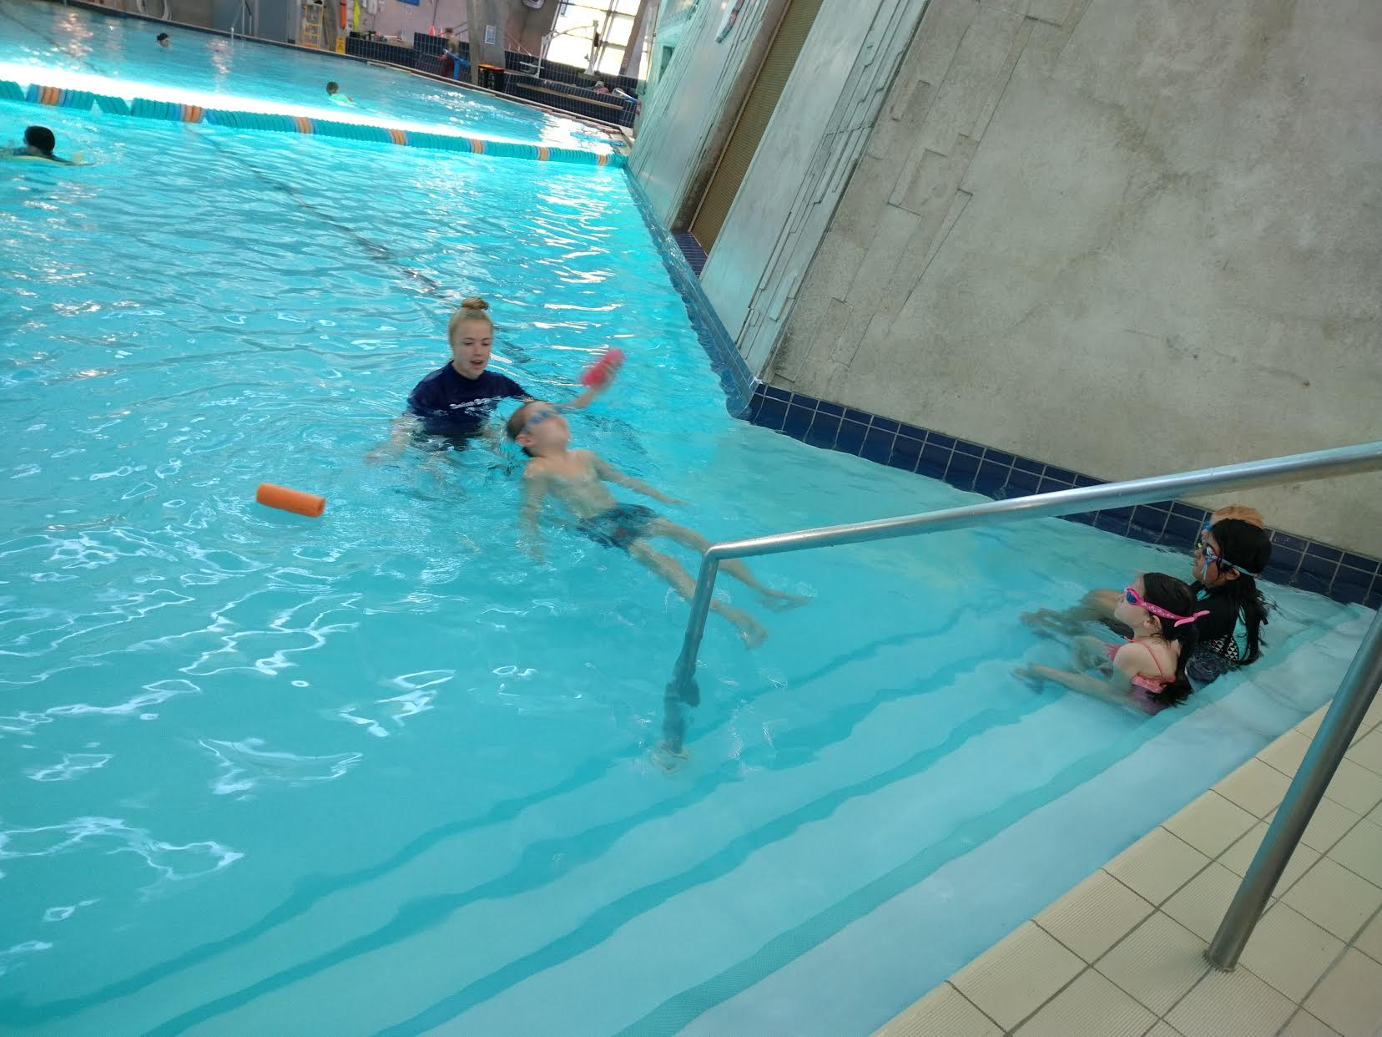 | 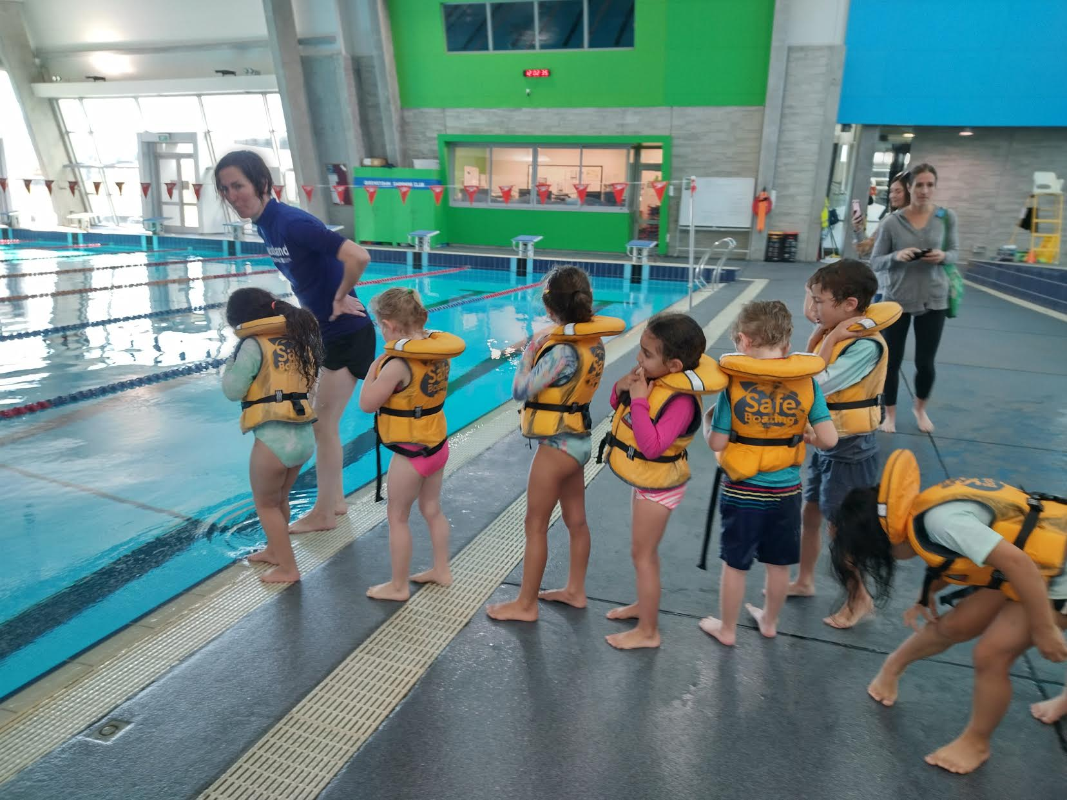
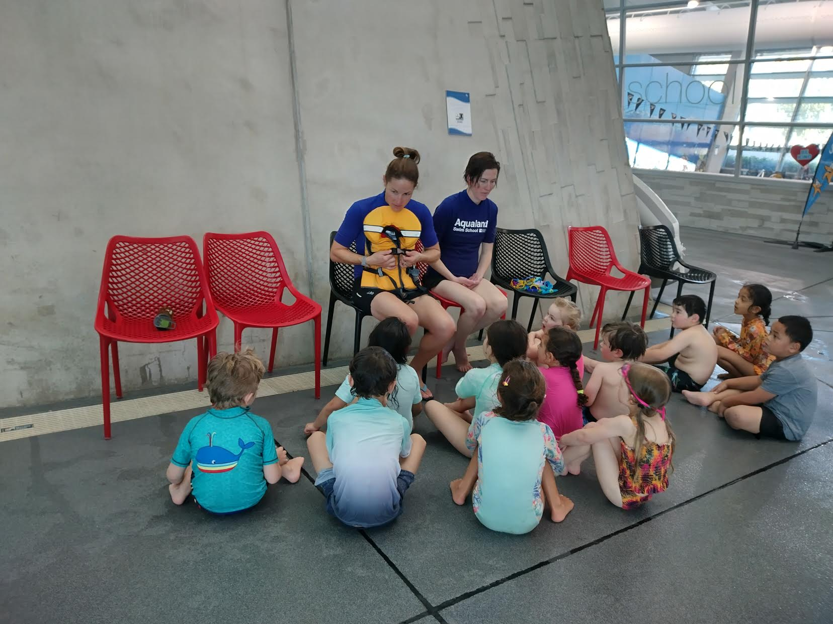 | 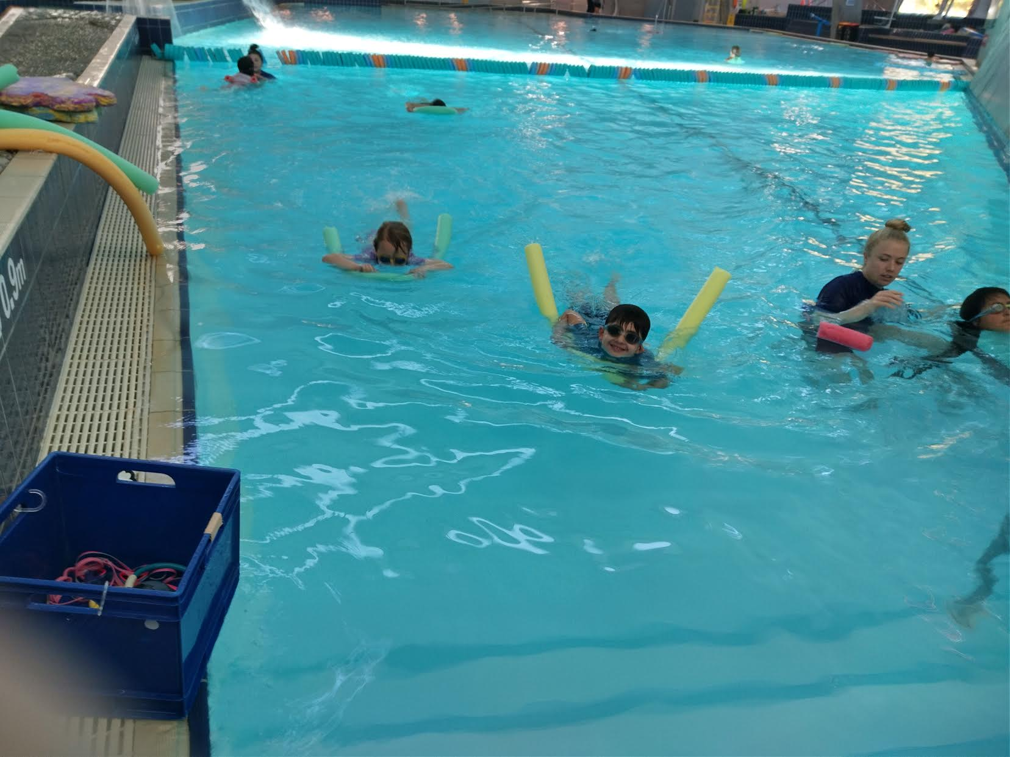
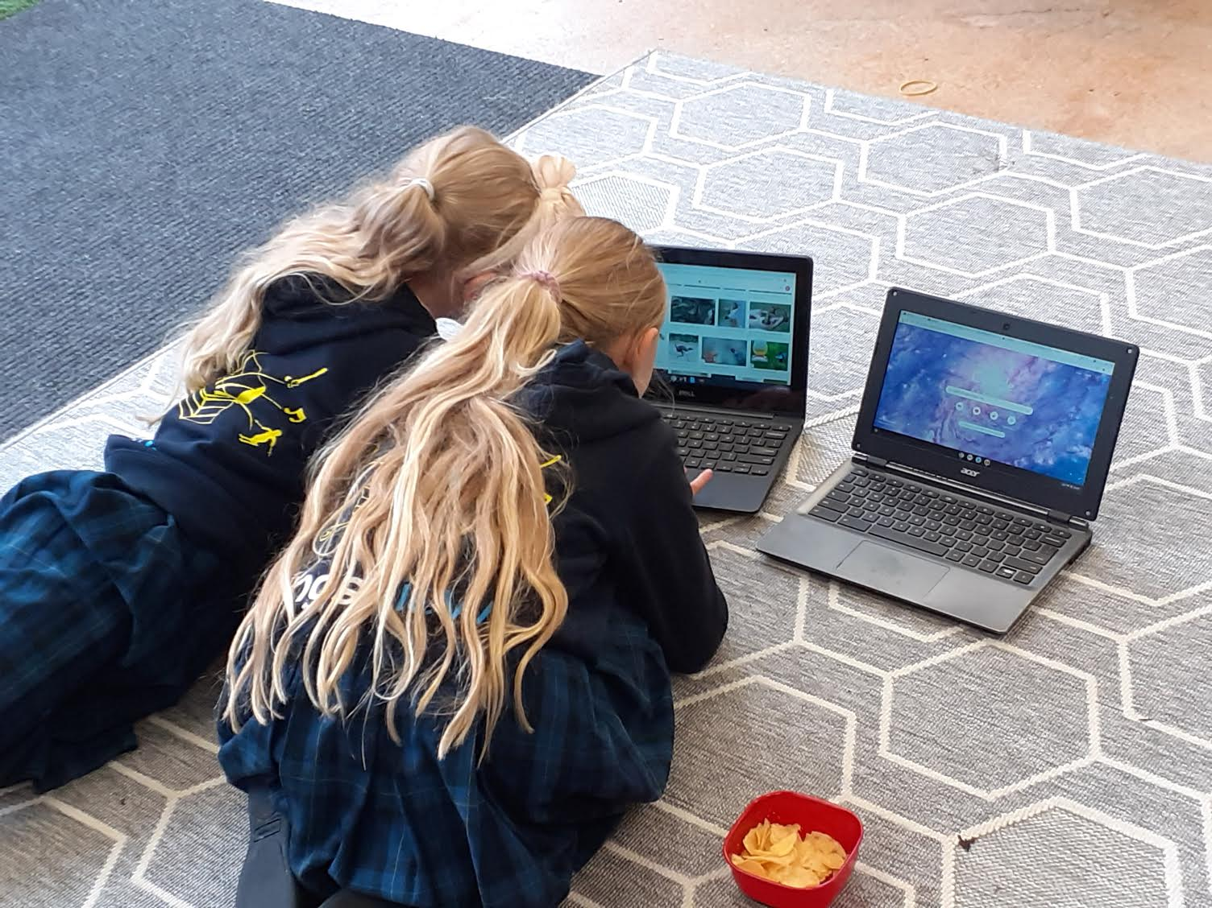 | 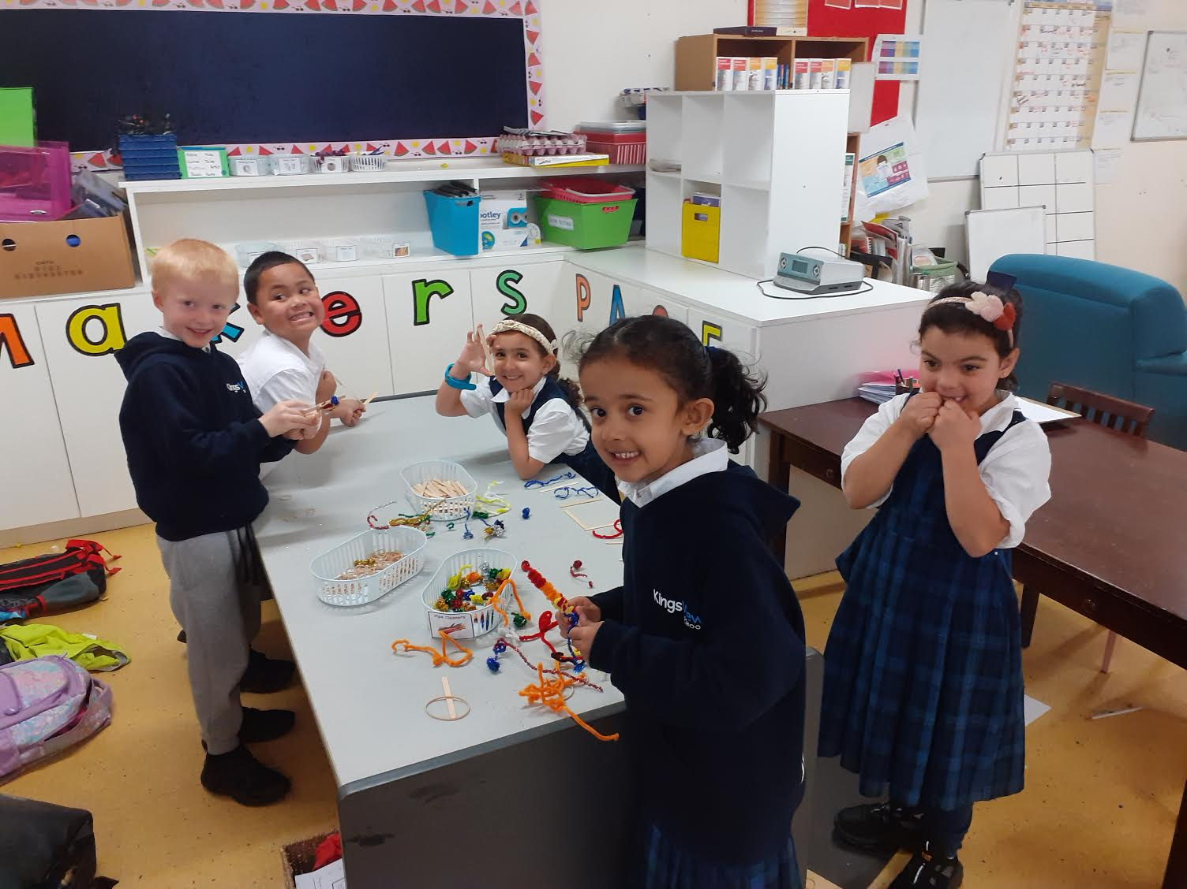
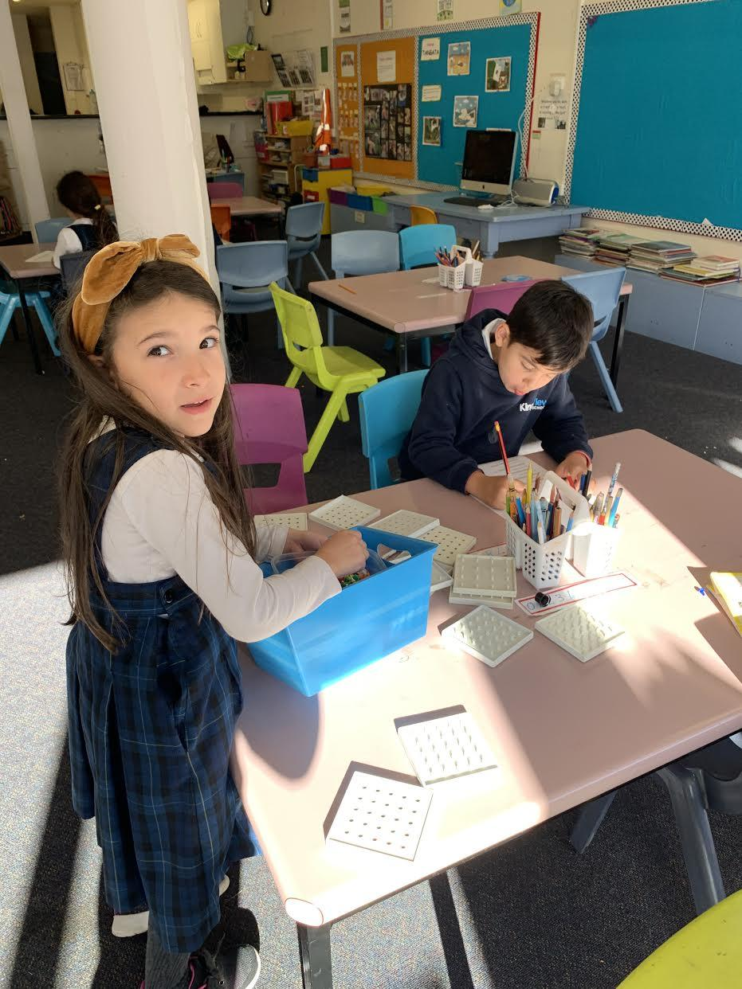 | 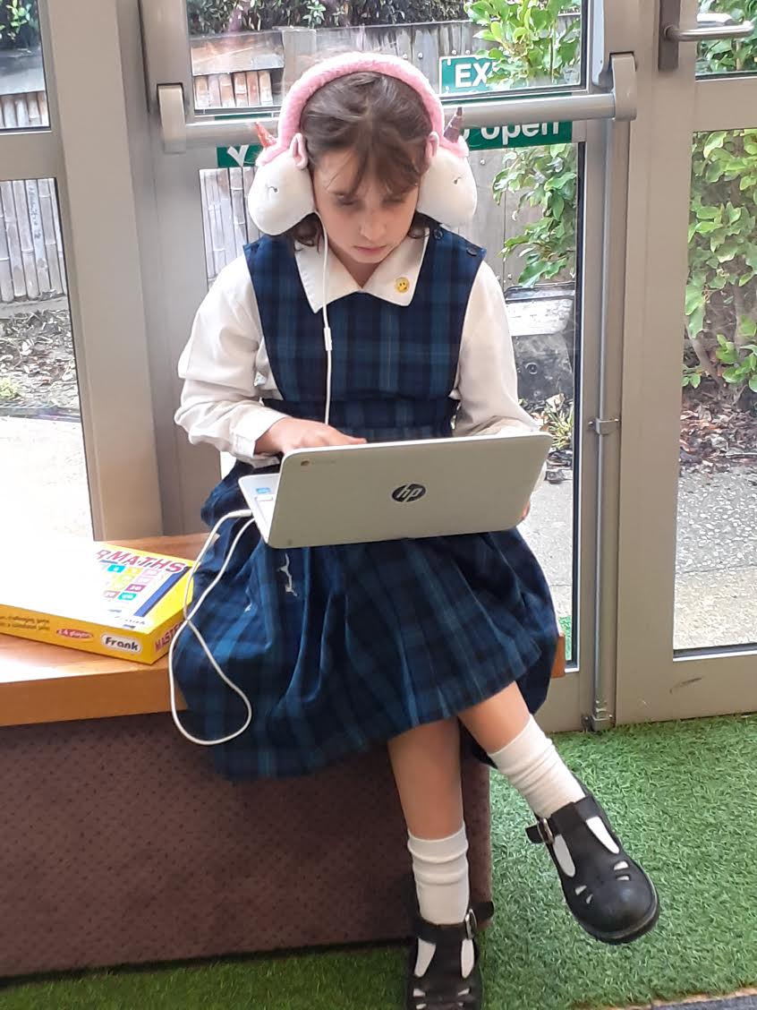

COMMUNITY NOTICES:

Sushi Delivery

Suma Sushi will not have any food deliveries for the next two weeks due to a family bereavement in Australia.

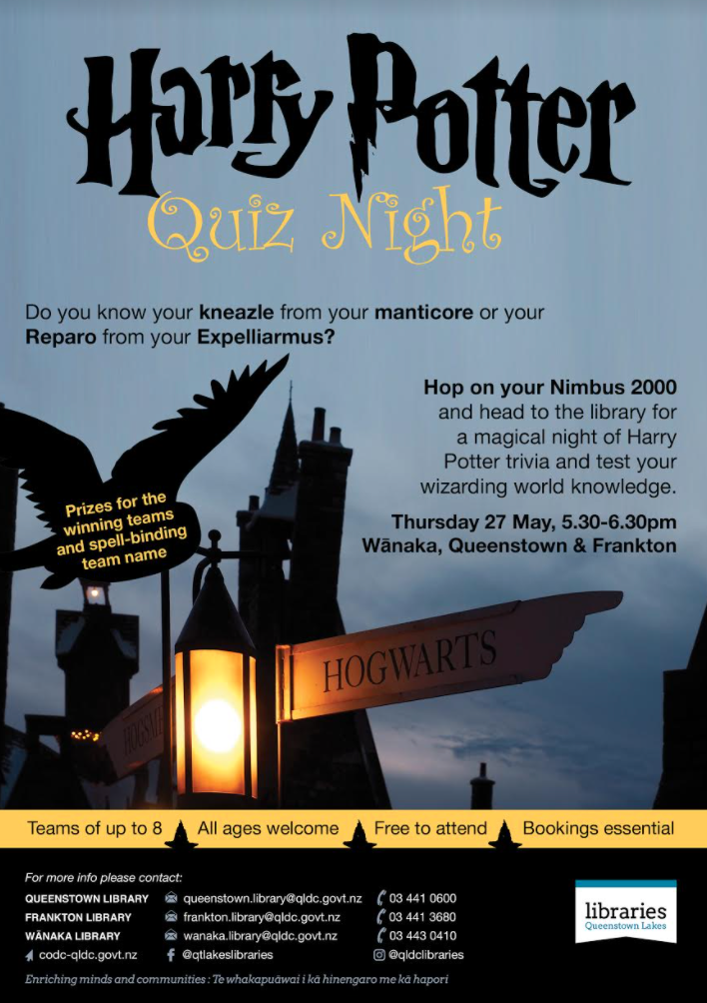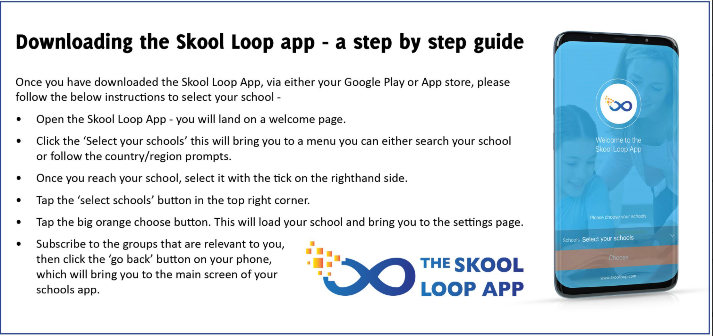
Have you set up Skool Loop yet?

